
University of Technology and Applied Sciences
General Foundation Programme
Midterm Exam
Level 2
Fall Semester 2022-2023
Reading
Duration: 60 minutes

Name

Student Number
Group

Section 1 (10 marks)
Section 2 (15 marks)
Total (25 marks)

Marker’s Initials

Four Unusual Schools
Read about four of the world’s most unusual schools and answer questions 1-10.

Green School is located in the jungles of Bali near the Ayung River in Indonesia. John Hardy and his wife, Cynthia, founded the school in 2008. A German carpenter, Jorg Stamm and a Swiss sculptor and designer, Aldo Landwehr, built the school building. The building and the classroom furniture are made out of bamboo. The eco-friendly school uses clean energy from the sun, wind and water. The school provides green education to the students. Students learn subjects such as river ecology and rice cultivation. |  |  | Green School  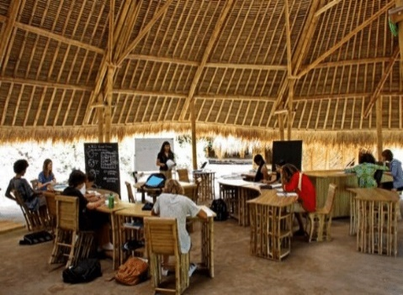
School of the Future   | Created with the help of the software company, Microsoft, School of the Future uses innovative teaching methods and the latest technology. The school opened in West Philadelphia, U.S.A in 2006. It cost the school district $63 million to build this school. Students carry laptops instead of books. They study Math and Science on various Microsoft apps like One Note. Students have digital lockers in the school that they open with an ID card. The school begins at 9:00am and ends at 4:00pm like a normal work day instead of a typical school day.
Established by Maurice De Hond in 2013, Steve Jobs schools in the Netherlands allow children to learn at their own pace. Each student starts with an Individual Development Plan made by the child, his or her parents, and the school coach. In these schools, the teacher is called a ‘coach’. All students receive iPads fully loaded with apps to guide their learning. Students use these to study, play, share work, prepare presentations and communicate with others. |  |  | Steve Jobs schools  
Brooklyn Free School  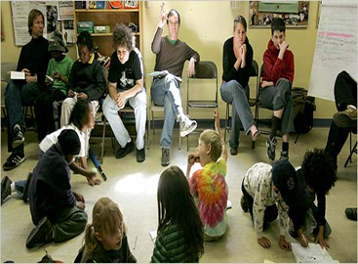 |  | Founded in 2004 in New York City, Brooklyn Free School is a unique school. Brooklyn Free School has no grades, no tests, no compulsory classes or homework. Students are free to choose the subjects they want to study. Students make the school rules. They decide if they want to study, to play, to wander around or just sleep. On Wednesday mornings, the entire school comes together to attend a weekly meeting to discuss important issues and take decisions together.

READING SECTION 1

Questions 1 to 10

Read the scanning sheet about Four Unusual Schools and answer the questions.

You may write your answers on the question paper, but you MUST transfer your answers to the answer sheet before the 60 minutes are over. You will NOT be given any extra time at the end to do this.

Write no more than TWO WORDS AND/OR A NUMBER for each answer.
Write the answer in the correct space on your answer sheet.

Answers with incorrect spelling will be marked wrong.

1. When are weekly meetings at Brooklyn Free School?

2. What is the nationality of the carpenter who built the Green School?

3. Who is known as a ‘coach’ in Steve Jobs schools?

4. Who makes the school rules at Brooklyn Free School?

5. Which school was started by a married couple?

6. How much did it cost the school district to build the School of the Future?

7. What have the Green School builders used to make classroom furniture?

8. What do School of the Future students use to open their digital lockers?

9. In which country can you find Steve Jobs schools?

10. What do students carry instead of books in the School of the Future?

READING SECTION 2

Read the passage and answer the questions.

You may write your answers on the question paper, but you MUST transfer your answers to the answer sheet before the 60 minutes are over. You will NOT be given any extra time at the end to do this.

A
Football is an extremely popular world sport. Young men look up to famous footballers as role models. Several football stars began their sporting careers as children playing on the streets. However, many of them moved on to join football academies, or sports’ schools, to build their talent and become professional players.
B
A football academy is a school set up to develop young footballers. All major football clubs
such as FC Barcelona, Manchester United and Real Madrid have their own academy.
They scout, or look for, young talent and then teach them to play football to meet the club's standards at the academy.
C
Football academies provide football education to students who are 21 years old and below. A student must be at least 9 years old to join an academy. However, some football clubs, such us Arsenal, have pre-training programmes for even younger players. All the boys at an academy continue their normal school education. It is important that they are able to get good jobs in case they fail to become professional footballers.
D
Players between the ages of 9 and 16 have to sign schoolboy forms. They sign a new contract every two years. When the player turns 16, the academy decides if they are going to offer the player a place on their Youth Training Scheme. Each year, the best players receive a scholarship. This gives them free football training and an academic education.
E
In a football academy, players attend training sessions in the afternoon on weekdays, and in the morning at weekends. On Sundays, they don’t train. They play matches against other academy teams. The football academies also encourage their players to take up other sports such as gymnastics or basketball.
F
FC Barcelona's football academy, La Masia, is one of the best football academies in the world. Located in Barcelona, Spain, La Masia has over 300 young players. Famous footballers and coaches such as Lionel Messi, Pep Guardiola and Ces Fabregas are graduates of La Masia. Many people think that Barcelona’s success in the football world is due to the excellent training programme provided at La Masia. Today, FC Barcelona has academies in other parts of the world including Egypt, Japan, America and Dubai.

Questions 11 to 15

The Reading passage has 6 paragraphs, A-F.

Read the following headings 1 to 6 and choose a suitable title for each paragraph. Write the correct number on your answer sheet. The first one has been done for you as an example. (WRITE ONLY THE CORRECT NUMBER)

Headings

1. From the streets to an academy
2. Agreements between young players and the academy
3. An academy that produced some famous names in football
4. Weekly routine of players in the academy
5. An academy for each big club
6. Learning about football but still going to school

Paragraphs

Example: A = 1
11. B =
12. C =
13. D =
14. E =
15. F =

Questions 16 to 18

Do the following statements agree with the information given in the Reading Passage?
In the correct space on your answer sheet, write

TRUE (T) if the statement agrees with the information
FALSE (F) if the statement disagrees with the information
NOT GIVEN (NG) if the information is not in the passage

16. All famous footballers went to football academies.

17. Only a few important football clubs run their own football academies.

18. Most players join a football academy at 9 years of age.

Questions 19 to 21

Choose the correct letter, A, B or C.
Write only the correct letter on your answer sheet.

19. Football academies take students

A. under the age of 9.
B. between the ages 9 and 21.
C. only between the ages of 9 and 16.

20. Football academies

A. give scholarships to all players over 16.
B. renew the contracts of players each year.
C. may or may not accept a player on the Youth Training Scheme.

21. Football academy students

A. cannot play other sports.
B. play against other teams on weekdays.
C. don't have training sessions on Sundays.

Questions 22 to 25

Complete the summary below using words from the box. The words are from the passage. Write your answers on your answer sheet.

Answers with incorrect spelling will be marked wrong.

academies famous training clubs

The world's important football 22. ___________, such as FC Barcelona, and Real Madrid have their own football schools. Located in Barcelona, Spain, La Masia is among the top
23. __________ for football coaching. Lionel Messi, Pep Guardiola and Ces Fabregas are
24. ___________ players or coaches from La Masia. A lot of people believe that La Masia's extremely good 25. ___________ programme is a reason for FC Barcelona's success in football.

University of Technology and Applied Sciences
Level 2, Midterm Exam, Fall Semester 2022-2023
Name: _________________________________________ Student ID: ________
College: ________________________________________ Group: ___________
Answer Sheet
Reading |  | Marks
1. |  | /10
2. |  | /10
3. |  | /10
4. |  | /10
5. |  | /10
6. |  | /10
7. |  | /10
8. |  | /10
9. |  | /10
10. |  | /10
11.
12.
13.
14.
15.
16. |  | /15
17. |  | /15
18. |  | /15
19. |  | /15
20. |  | /15
21. |  | /15
22. |  | /15
23. |  | /15
24. |  | /15
25. |  | /15
For the Use of examiners only
Total Mark | Marker

