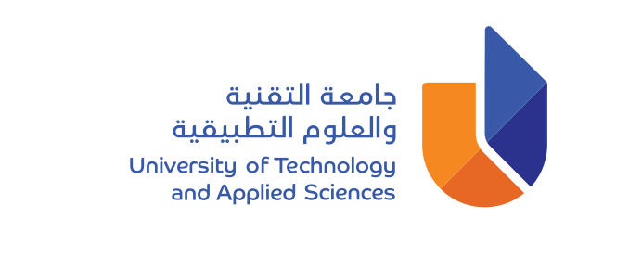
University of Technology and Applied Sciences
General Foundation Programme
Midterm Exam
Level 2

Fall Semester 2022-2023
Listening

Name

Student Number
Group

Section 1 (10 marks)
Section 2 (5 marks)
Section 3 (10 marks)
Total (25 marks)

Marker’s Initials

SECTION 1 Questions 1-10
Listen to a student called Taimur speaking to his classmate about his summer course, and as you listen answer questions 1 to 10.
You will hear the conversation twice.
At the end of the listening part, you will have 6 minutes to transfer your answers to the answer sheet.
Questions 1-3

Do the following statements agree with the information given in the recording?

TRUE (T) if the statement agrees with the information
FALSE (F) if the statement disagrees with the information

- Taimur went to Europe to visit tourist sites.
- Hanan is surprised to learn about Taimur’s interest in cooking.
- Hanan doesn’t like to cook.
Questions 4-7
Choose the correct letter, A, B, or C
- Taimur’s mother thinks that

A. it isn’t important to study Math and Physics.
B. only girls must learn to cook.
C. teenagers must learn different skills.

5. Some of Taimur’s cooking lessons were

A. at weekends.
B. outside the school kitchen.
C. in food factories.

6. The term ‘Toque blanche’

A. is made of two French words.
B. means a ‘tall hat’.
C. means a ‘white hat’.

- Taimur didn’t like

A. doing the dishes.
B. the smell of the food.
C. cleaning the kitchen.

Questions 8-10

Write no more than ONE WORD AND/OR A NUMBER for each answer.

Write the answer in the correct space on your answer sheet.

Answers with incorrect spelling will be marked wrong.

8. How many euros did Taimur pay for the cooking course?
9. Which Italian rice dish will Taimur cook for the class party?
10. When is the class party?

SECTION 2 Questions 11-15
Listen to a conversation between two students and their teacher about learning languages, and as you listen answer questions 11 to 15.
You will hear the conversation twice.

Answer the questions below using NO MORE THAN ONE WORD AND/OR A NUMBER for each answer.

Answers with incorrect spelling will be marked wrong.

Language Nawal is learning | 11. ______________
Length of the Elementary course at Pathway Institute | 12. _____________
Country Mr. Downey worked in before coming to Oman | 13. ___________
A person who can speak many languages | 14. _____________
Smartphone app Haitham can use to learn Spanish | 15. ____________

SECTION 3 Questions 16-25
Listen to a talk about education now and in the past, and as you listen answer questions 16 to 25.

You will hear the talk twice.

Questions 16-20

Choose the correct letter, A, B, or C.

16. In America, education in grade school begins when children are aged about

A. 6.
B. 11.
C. 14.

17. When high school finishes in the United States, students

A. must go to private colleges and universities.
B. have to attend trade schools or community colleges.
C. have a number of different options.

18. In the earliest times in most countries, parents taught children by ____________ to them.

A. reading
B. speaking
C. writing

19. When schools began, the students were mainly

A. males
B. females
C. leaders.

20. Many schools concentrated on military training and public speaking to

A. produce religious leaders.
B. train the leaders of the future.
C. produce leaders skilled in art.

Questions 21-25

Complete the sentences below.

Write no more than ONE WORD or A NUMBER for each answer.

Answers with incorrect spelling will be marked wrong.

21. The home was the place for the education of the majority of _________________.
22. Public systems of education appeared in a number of ______________ in the 1800s.
23. Many of the first schools in America taught students in one ____________.
24. The first American secondary school opened in ____________________.
25. In the 1900s, _______________ for teachers started to open.

University of Technology and Applied Sciences
Level 2, Mid Term Exam, Fall Semester 2022-2023
Name: _________________________________________ Student ID: ________
College: ________________________________________ Group: ___________
Answer Sheet
Listening |  | Marks
1. |  | /10
2. |  | /10
3. |  | /10
4. |  | /10
5. |  | /10
6. |  | /10
7. |  | /10
8. |  | /10
9. |  | /10
10. |  | /10
11. |  | /5
12. |  | /5
13. |  | /5
14. |  | /5
15. |  | /5
16. |  | /10
17. |  | /10
18. |  | /10
19. |  | /10
20. |  | /10
21. |  | /10
22. |  | /10
23. |  | /10
24. |  | /10
25. |  | /10
For the use of examiners only
Total Mark | Marker

