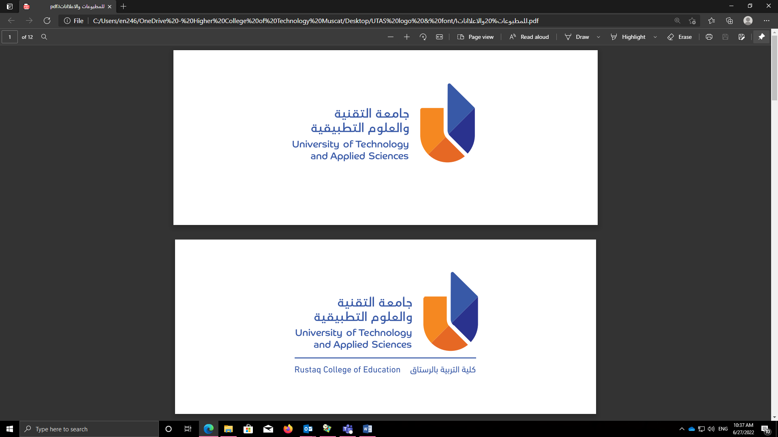
University of Technology and Applied Sciences
Level 2, MTE, Fall Semester 2022-2023
Answer Key

Reading
1. | WEDNESDAY MORNINGS
2. | GERMAN (NATIONALITY)
3. | (THE) TEACHER
4. | (THE) STUDENTS
5. | GREEN (SCHOOL)
6. | $63 MILLION
7. | BAMBOO
8. | ID (CARD)
9. | (THE) NETHERLANDS
10. | LAPTOPS
11. | 5
12. | 6
13. | 2
14. | 4
15. | 3
16. | FALSE/F
17. | FALSE/F
18. | NOT GIVEN/NG
19. | B
20. | C
21. | C
22. | CLUBS
23. | ACADEMIES
24. | FAMOUS
25. | TRAINING

Note: Spelling and grammar must be correct. Any answers over the word count must be marked as incorrect. Words in brackets are optional. Answers may be written in upper or lower case. Alternative acceptable answers are indicated after a back slash. Numbers may be written using numerals or words.

